**ONE LINE COMMAND:-**

1. cd :-



2.echo:-

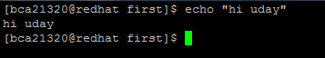

3. pwd:-



4.rmdir –p:-



5. tty:-



6. stty:-



7. clear:- to clear the screen

8.exit :- to exit the shell